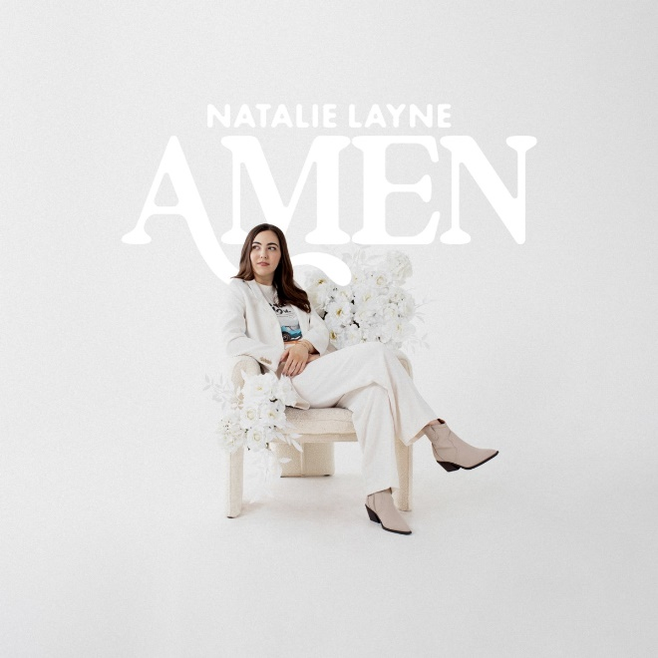

Natalie Layne

Joy. Natalie Layne radiates it. From her original songs to the way she talks about Jesus, the Centricity Music recording artist is filled with joy from every square inch of her tall, six-foot frame. Joy is also easily the common thread woven throughout her introductory EP, Amen, a debut offering that speaks to the power of finding the good in moments that don’t necessarily feel good. Yet, joy isn’t the only emotion that exudes from Amen. The newcomer also emits a confidence that’s rare for a recently signed artist rooted in six years of pursuing her craft independently. Namely because — whether signed or independent — Layne always perceived music would be a part of her story.

With a family history steeped in melodies and her grandmother serving as her piano teacher, the Colorado Springs native remembers God nudging her more specifically toward artistry during high school. At the end of her senior year, a family friend produced a few of her original songs and helped her record them. She released an additional handful of tracks at the end of college, and that’s when the pieces began falling into place for the accomplished musician. “Just personally as a songwriter, I wanted there to be markers for the songs I was writing,” Layne explains. “And then the songs ended up helping people and meaning something to people, and I went, ‘OK, this could really matter.’”

A turning point came when she played the widely-respected Christian Showcase during her senior year at Belmont. With numerous Nashville A&R executives in attendance, Layne received multiple calls after she and her band — with whom she’d been playing since junior high — won the entire showcase.

Promising label conversations followed but came to an abrupt halt when the global health crisis hit in early 2020. That’s when Layne decided to pivot and work toward a master’s in commercial piano, while continuing to maintain her burgeoning career as an indie at a time when artists were unable to tour.

Armed with a second degree, Layne emerged from the pandemic poised to pursue whatever opportunities unfolded. After label conversations resumed, four years following their initial dialogue, Layne signed an exclusive recording and publishing contract with Centricity Music. But even prior to partnering with a record label, the savvy, tenacious singer was already carving a unique path.

As an independent artist, Layne cultivated an impressive social following simply by inviting listeners into her songwriting process online. Moreover, she studied under GRAMMY® award-winning songwriter and producer Bernie Herms (Natalie Grant, Josh Groban, Barbra Streisand) through an apprenticeship that allowed her to shadow him for a semester. She’s sung background vocals for Natalie Grant on the Dove Awards stage and also lent BGVs to labelmate Jason Gray’s upcoming album. Additionally, she’s opened shows for Jeremy Camp, Chris Tomlin and We The Kingdom, among others; and she’s headlined full band sets at Bonnaroo — twice. Amen builds on her growing momentum, serving up six original songs — all co-penned by Layne.

The title-cut bears a name the singer/songwriter had tucked away for quite some time. “It’s such a small thing that can inspire a song sometimes,” she offers. “There’s a lot of hard things happening in the world, and I just felt so heavy one particular week. I was driving out of my neighborhood, and one of my neighbors was out on their morning walk. They waved and smiled as I drove by, and it restored my faith in humanity for a second.”

Together with collaborators Benji Cowart and David Spencer, Layne wrote that seemingly insignificant gesture into the bridge of what became “Amen.” “I started thinking, ‘What if there was a song where we could say ‘amen’ to all the good things happening in the world and not discount the hard things?’” she shares. “We need to acknowledge the broken things, but there’s actually a higher reality at work in the world. There’s still joy even when hard things are happening. Grief and gratitude can exist at the same time.”

This shift in perspective undoubtedly yields thankfulness, and viral TikTok track “Grateful For” evokes a great deal of gratitude. Layne commenced the cheerful chorus the same way she begins most of her songs — by playing a series of notes on piano. As she started plucking out a lighthearted melody, her co-writer, Mitch Wong, observed, “That sounds like gratitude.” So that’s the exact sentiment the pair, along with Jimmy James, captured that day. “I smile every time I listen to it,” Layne says.

Closing track “Arms of God” also elicits a wide grin from the singer. It’s the first song she’s ever released that she’s produced solely by herself. The intimate selection is built on piano and filled out with lush strings that really allow her friendly vocal to shine. “That song feels a lot like me,” Layne comments. “It feels the way I’ve always wanted my music to sound.”

While her sonic direction is as welcoming as a friend and as cohesive as that of a seasoned act, the message behind her music stems from personal experience. After growing up in the church, during her teen years, Layne recognized she had to make her faith her own and determine what she believed apart from her parents. This became even more crucial when she began leading worship under the mentorship of respected worship pastors such as Cory Asbury, Jon Egan and Jared Anderson. She penned the half dozen songs that comprise Amen for that teenage girl in the thick of unraveling her own convictions.

“I want to talk about the power of staying. Sometimes finding the Lord for yourself and choosing to stay can be harder than leaving, but life with Jesus really is better. It’s not perfect, but it’s way better,” she shares. “I want to write songs for the lifelong church kids, but at the same time, I want people who have left or who are far off to hear these songs and be called back home. No matter which end of the spectrum people find themselves on, I want to give them permission to feel like their story matters.”

It’s also her desire that everyone’s story be marked by the same kind of joy she’s experienced through choosing to follow Jesus. And that’s the overarching banner that will consistently encircle her art.

“I’ve just always wanted to make music that brings people joy. I think we need joyful songs to get us through the day sometimes, and God’s given me a lot of permission to go for the happy songs,” Layne says. “If these songs could bring people joy, even in little ways, that would be a win.”

# # #

