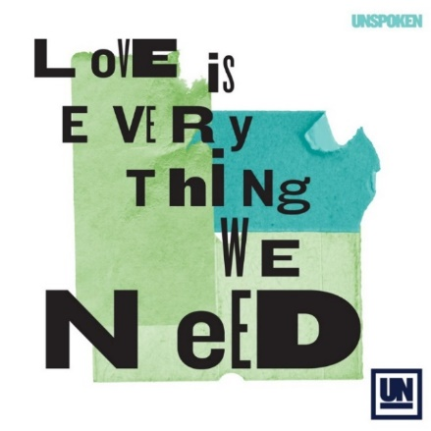 |  | 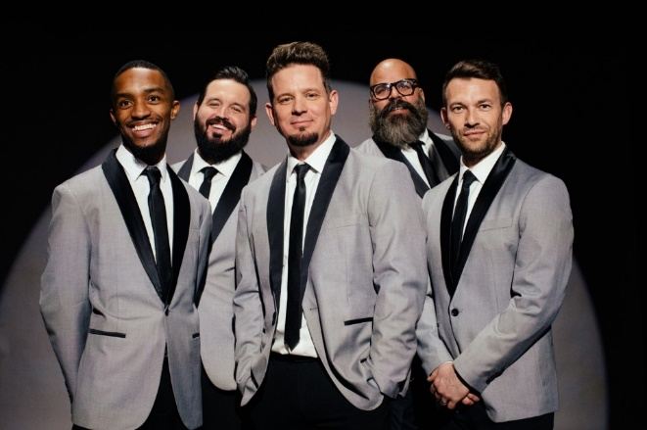

Unspoken

It’s been three years since Unspoken released a full-length album. In those three years, a global pandemic forced them off the road, their drummer nearly died from COVID, and they suffered multiple lineup changes. All of this transpired amidst a cultural backdrop of division and hatred. Taking both their personal hurdles and their mutual grief into the studio with them, the band began crafting their next record. The theme that quickly emerged? Love. While it might sound trite or simplistic, the reality — as the group soon discovered — is that it’s everything we need.

Unspoken’s upcoming LP — their fourth studio project — follows 2019’s Reason, whose title track became the band’s biggest multi-format chart-topper to date. The album also produced a pair of Top 20 singles: “You’ve Always Been” and “Just Give Me Jesus.” Since their self-titled debut in 2014, the five-piece has charted a parade of hits led by Chad Mattson’s unmistakable vocal, including “Who You Are,” “Lift My Life Up,” “Good Fight” and “Start A Fire,” which became the collective’s first No. 1. Moreover, their career has been fueled by Mattson’s transparency as a songwriter who’s battled addiction and is now nearly two decades into his sobriety. Along the way, Unspoken has shared the stage with TobyMac, Casting Crowns, MercyMe and Big Daddy Weave, among other artists, living out their mission to be unspoken testimonies to God’s love and power and to speak what oftentimes goes unsaid.

Their new music aims to continue to bring unspoken truths to light. In a culture that regularly takes cheap shots online, Unspoken wants to point people to the truth of God’s Word. “Every song was inspired by a Bible verse that we were reading,” shares Mattson of the band’s anticipated album. “It’s been a journey in regards to writing the songs. Our words are less important than God’s words, so we just started praying and asking God to put His words into these songs.”

Although they’ve always been an act that’s endeavored to wrap melody around doctrinally-sound lyrics, recent events forced the members of Unspoken to stand on the promises of God more than ever before. “When all of our work went away because of the pandemic, we realized a lot of our identity is caught up in what we do and what we can accomplish,” Mattson confesses. “Not being able to accomplish anything really drew us to the Word of God.”

Their bandmate’s serious illness also steered them back to the basics after their drummer, Ariel Munoz, was hospitalized with COVID for nine days. “My oxygen got really, really low. It was 3 a.m., and I was dreaming I was drowning. Except I wasn’t dreaming — my body wasn’t getting any oxygen,” Munoz recalls, adding that the doctors were close to intubating him. “The only thing I remember is asking God for peace. By the grace of God, the numbers came up a little bit, and I came out of the danger zone later that morning.”

For Mattson and fellow bandmates Jon Lowry (bass), Zach Smith (guitars) and Matthew Callaway (keys), Munoz’s brush with death emphasized the deep brotherhood they possess. Mattson notes: “I think one of the things this whole season has taught us is just how important community is.”

They were also reminded of the unique bond they share with their fans as hundreds of prayers, cards and letters poured in with thoughts and messages of well wishes for Munoz. “The love and support we received from fans was super encouraging,” Mattson says.

“They called me the ‘rock star’ because of all the letters that came in every day,” Munoz adds, laughing. “It was amazing.”

The response from fans also affirmed the purpose behind Unspoken’s efforts. “Our job is to encourage people along the way, encourage people in their journey,” Mattson says. “Sometimes it’s to encourage people to be more like Jesus, and sometimes it’s to encourage people to accept what God’s Word says about them.”

Their timely track, “Loved By You,” focuses on the latter part of that mission, encouraging listeners to accept the love of God. “It’s so hard to understand God’s love, and it’s so hard to receive it. It’s so hard to understand that God loves us even in the midst of our mess,” Mattson reasons. “We don’t have to struggle and strive to earn God’s love. He gives it to us freely because we are His children, and His love changes us and allows us to love others in the same way. That is revolutionary when you think about it. That’s what this song is really about.”

Lead single “Love Is Everything We Need” looks at love from a different point of view. Mattson penned the upbeat, lighthearted offering following a disagreement with friends. “I have a lot of grace for people, but I also expect a lot of grace from people,” the frontman admits. “This song is a call to the Church to be in the world, but not of it, and to extend grace and love to people even when we don’t agree.”

Bringing the heartbeat of the song to life, Unspoken’s five members take on the role of wedding singers in the comedy-sketch-turned-clever-music-video. Hijinks ensue with a cast of surprising cameos from Victoria Jackson (Saturday Night Live), Richard Lee Jackson (Saved by the Bell: The New Class), Michele Pillar, Danny Gokey and more.

“Love Is Everything We Need” also marks the first song to feature Smith and Callaway, the band’s newest members — welcome additions Mattson says round out the group in a way that only God can. Sonically, their backgrounds are diverse: Smith brings a Southern Gospel/Country vibe; Callaway adds a soulful, Gospel feel; Lowry grew up on Steven Curtis Chapman and Paul Simon; Munoz was raised on a mix of Latin-infused beats and ’80s rock; and Mattson draws on hip-hop and R&B influences. Together, they form a cohesive blend of sounds, ideas and sonic textures — all rooted in their faith.

“It gives us a wonderful picture of the body of Christ and how a group of really different people can accomplish quite a bit together,” offers Mattson. “I love being a part of a band. It’s one of the greatest things I’ve been able to be a part of, outside of my family. Even through hardship, God has kept us together and used each one of our upbringings and experiences to allow us to make something beautiful.”

With their forthcoming album, Unspoken wants that beauty to lie in the meaning behind the music. “The whole goal is to encourage each other in the faith,” Mattson insists. “With this record, we want to encourage the body to live what the Word of God says, to believe what the Word of God says and to stand up for what the Word of God says.”

Perhaps the best place to start is 1 Corinthians 13:13: “And now these three remain: faith, hope and love. But the greatest of these is love.”

# # #

